**Subnets:**

**Public Subnet:**

* Has route for internet
* Residing Instances with public IP can communicate with internet

**Private Subnet:**

**No Route for internet**

**Instances receive private IP**

**Typically it uses NAT gateway / instances to connect with internet**

**Consider the below image.**

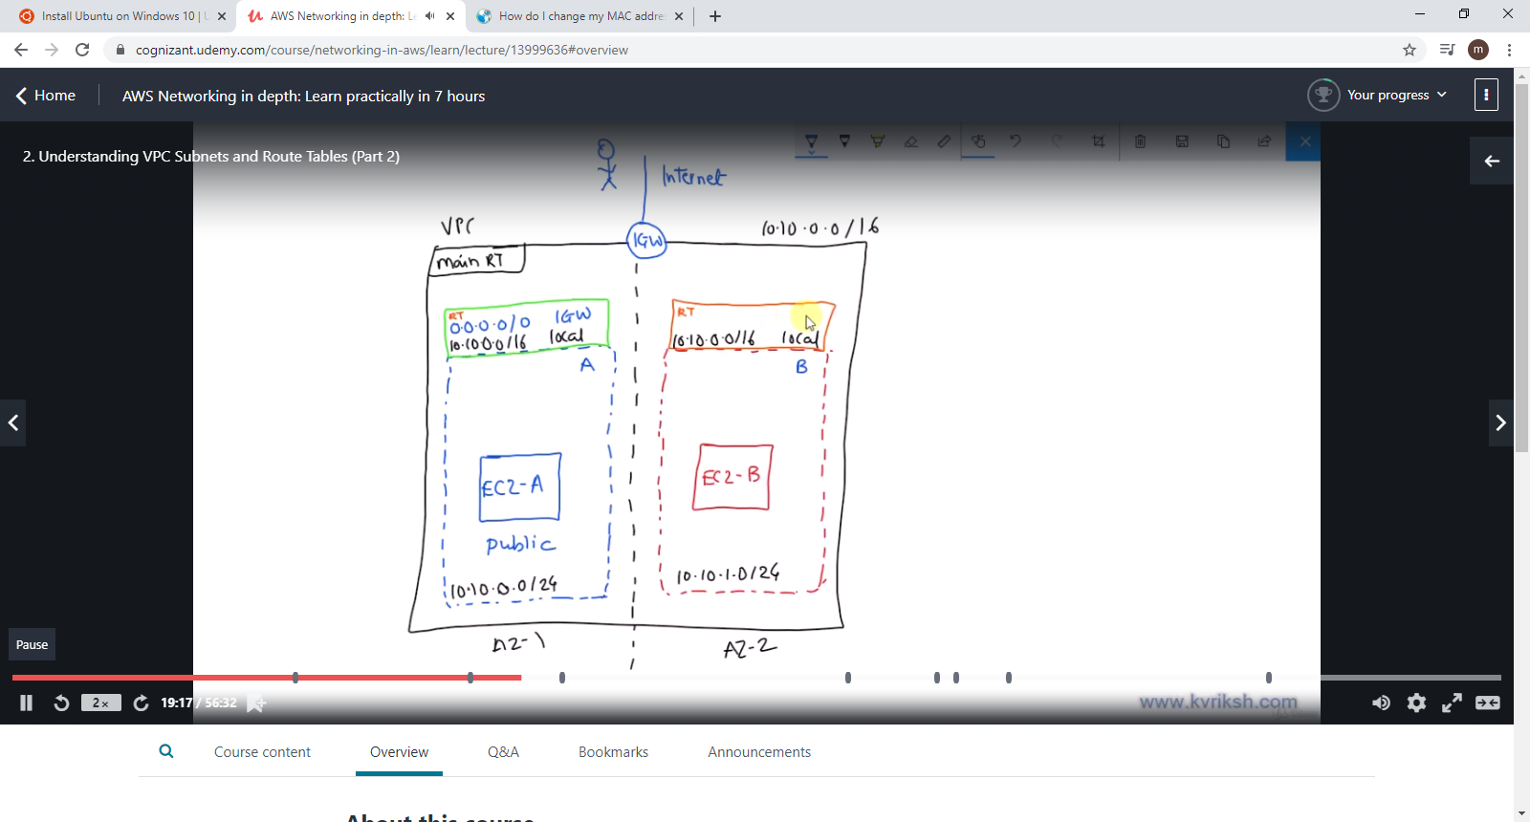

**Understandings:**

* **We have one VPC , which has two subnets**
* **Both subnets have subnet level route table**
* **We have Internet Gateway**
* **Subnet 1 has an entry to route to IGW &**
* **it has an EC2 instance with public ip**

**Subnet -1 can connect to internet - Hence, it is a public subnet**

**Subnet -2 can not connect to internet - hence, it is private subnet**